flowise-google sheet
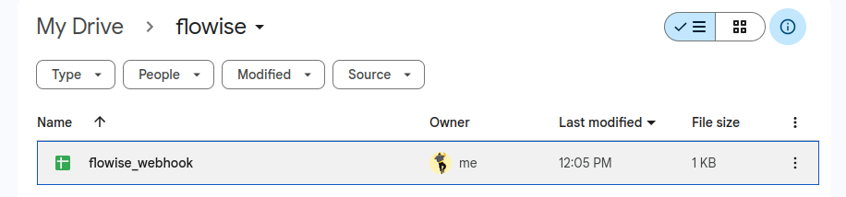Figure 1: Gsheet on my gdrive
Ref YouTube video
Date amended: 19th Feb, 2025
File: webhook Chatflow.json

A. Create and test webhook first

Steps
- Open your gdrive. And create a folder, say: flowise.
- Rightclick within the folder and create a google spreadsheet, say flowise_webhook. Press ctrl+s to save it.
- Rename Sheet1 to nodes. This step is optional.

- Write column heaaders: Node, Category and Action. These header-names (spellings, case) are very important.
- Create an account in make.com. My passsword is: Gautam*89023

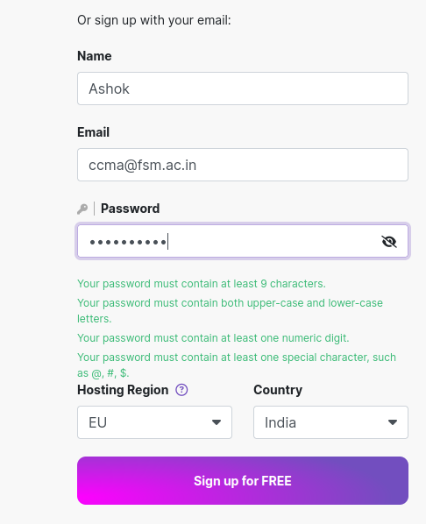

6. Loginto make.com. Select Template: Click Add Webhook data to Google Sheet

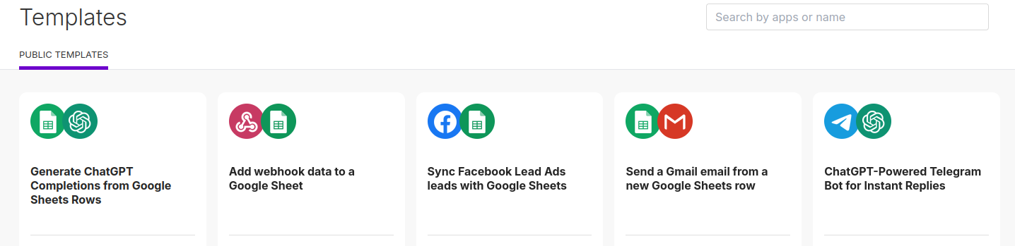Figure 2: Select Add webhook data to gsheet.

What is a Webhook
Webhook is a software interface (or a hook) between two applications. To set up a webhook, the client (google sheet) gives a unique URL to the server API (flowise) and specifies which event it wants to know about. Once the webhook is set up, the client (gsheet) no longer needs to poll the server; the server will automatically send the relevant payload (using http POST) to the client’s webhook URL (gsheet URL) when the specified event occurs.
Webhooks are often referred to as reverse APIs or push APIs, because they put the responsibility of communication on the server (flowise), rather than the client (gsheet). Instead of the client (gsheet) sending HTTP requests—asking for data until the server (flowise) responds—the server (flowise) itself sends the client a single HTTP POST request as soon as the data is available. Despite their nicknames, webhooks are not APIs; they work together. An application must have an API to use a webhook.
Read here in detail how make.com webhooks work.

- Template Selected.
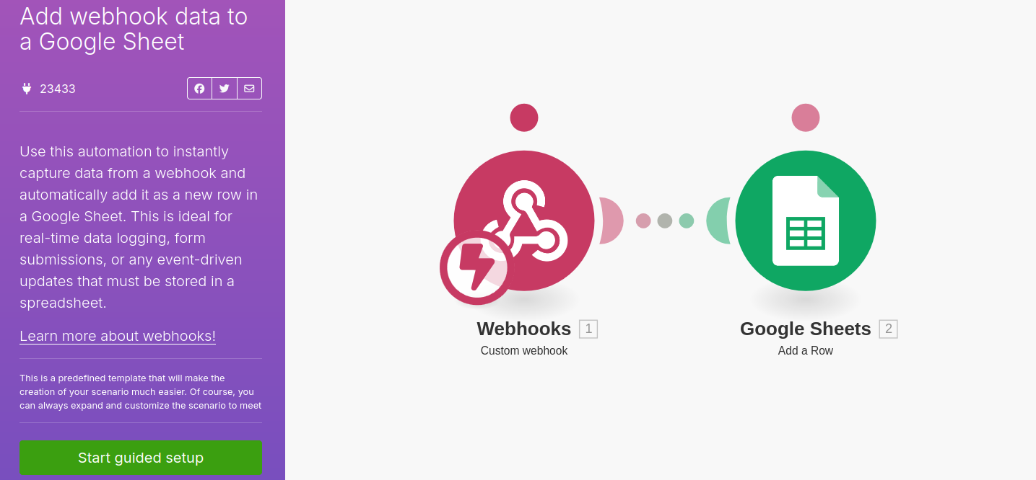Figure 3: Select a webhook-gsheet template. This specific webhook is customised for gsheet.

- Click on Start guided setup to setup template:
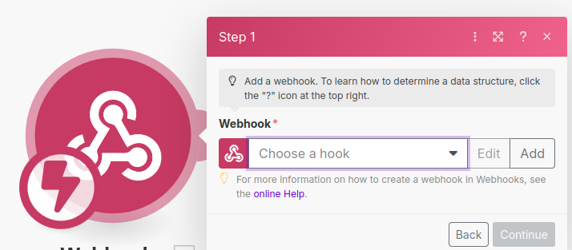Figure 4: Step1 of the guided workflow. Choose a hook from the drop-down.

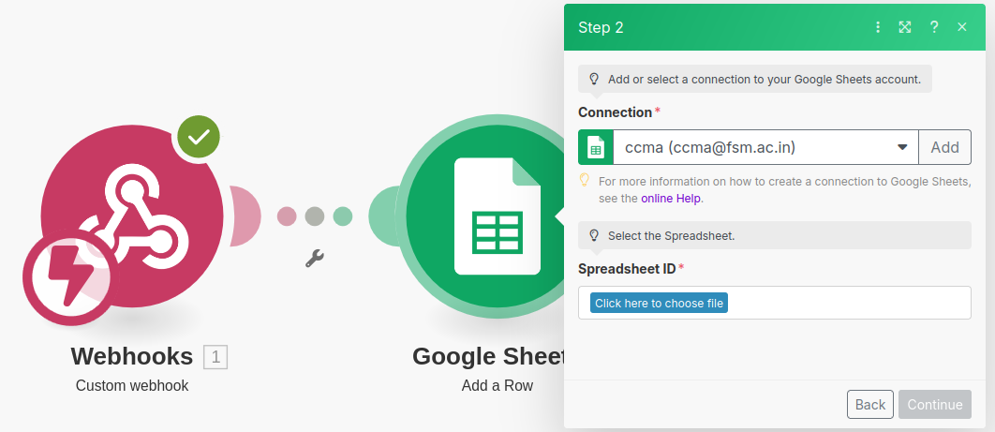Figure 5: In Step 2, set up Google sheet. Select your gsheet by name.

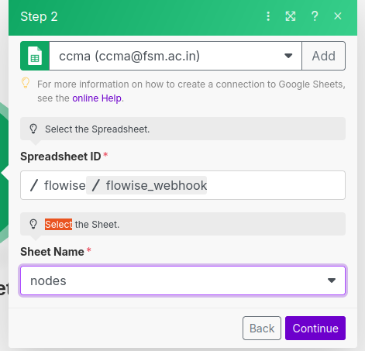Figure 6: Select also the Sheet (by name) ie whether Sheet1 or Sheet2 etc.

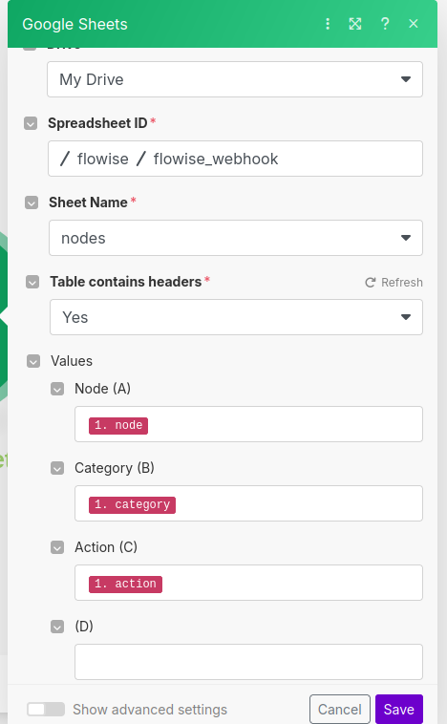Figure 7: Begin mapping json values to gsheet's header.

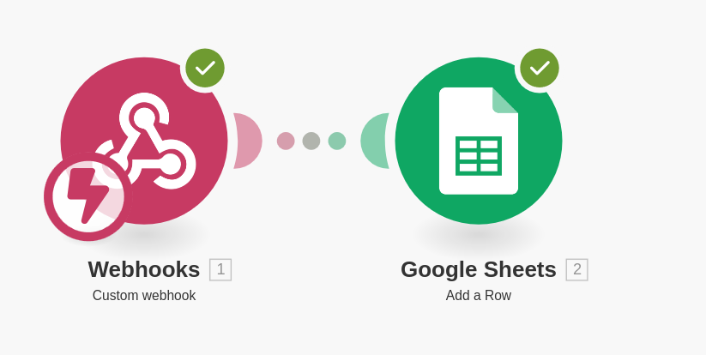Figure 8: Once mapping is done, test the webhook by sending messages through postman.

- Go to Postman and select: Send an API request.

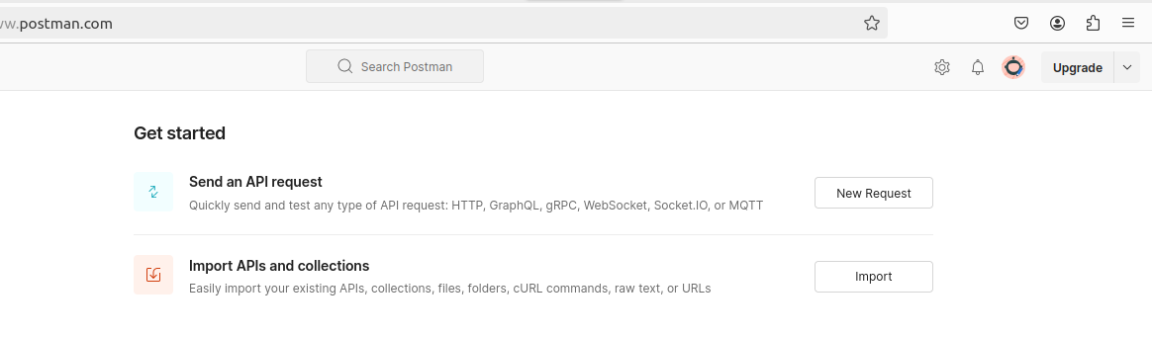Figure 9: Click Send An API request in Postman

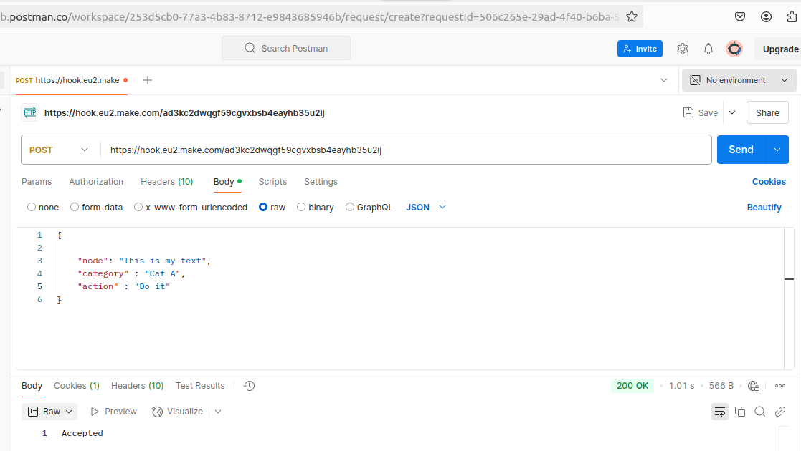Figure 10: Creating a message. The JSON message has three keys, each corresonds to the header of gsheet. It MUST have the same names as the gsheet header.

- Note the Green Colored sub-titles. Of names.
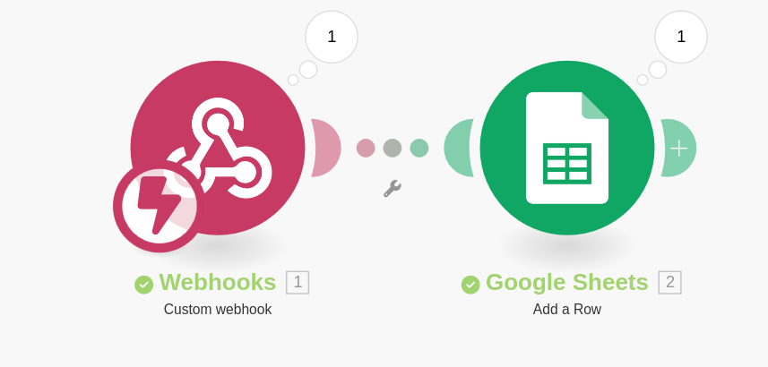Figure 11: Message from Postman received into gsheet.

- Check the logs in make.com by clicking on the last icon to the right of + or to the left of < at the bottom.

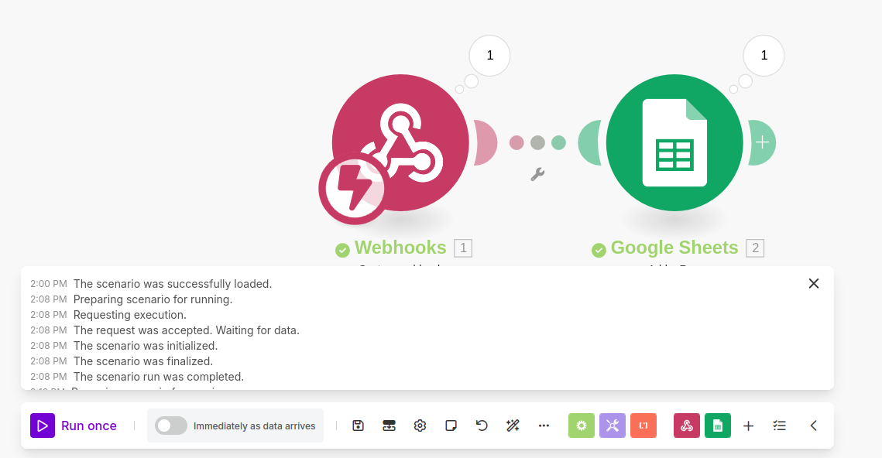

- Change webhook description scenarion and save (top-right) below.

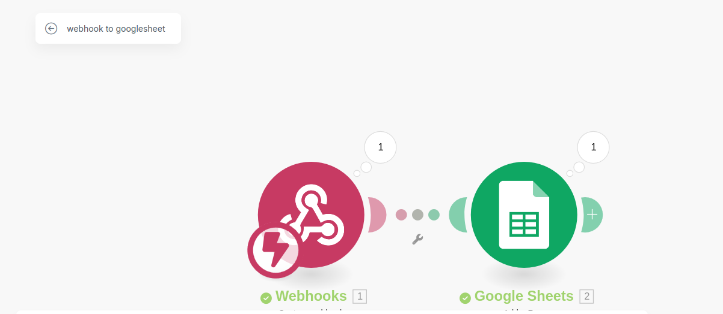

- Switch your sceanrion to ON:

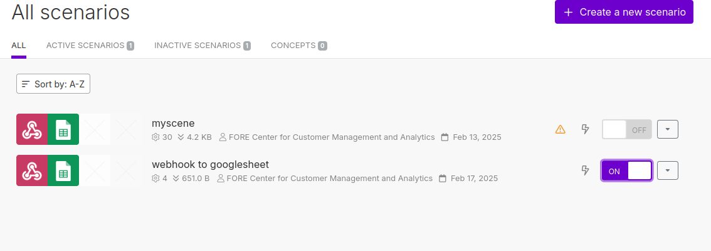

B. Workflow in Flowise:
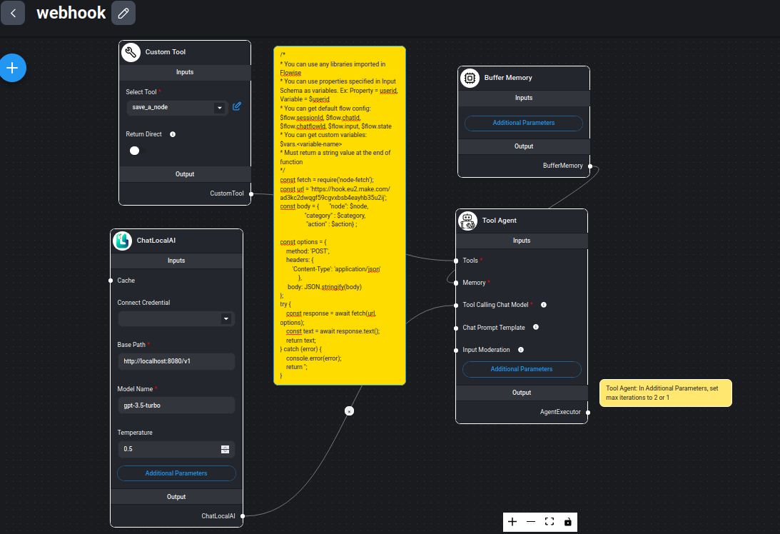Figure 12: Complete flow in flowsie

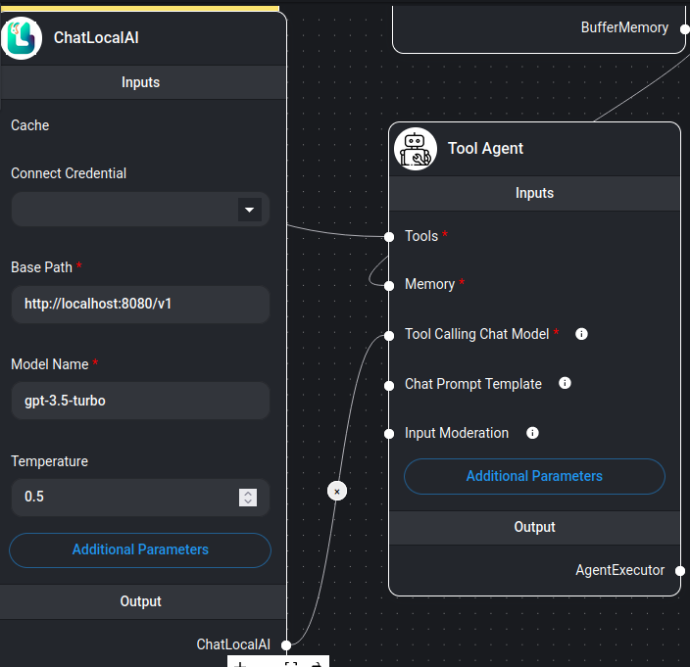Figure 13: In Tool agent under Additional parameters, set max iteration to 1

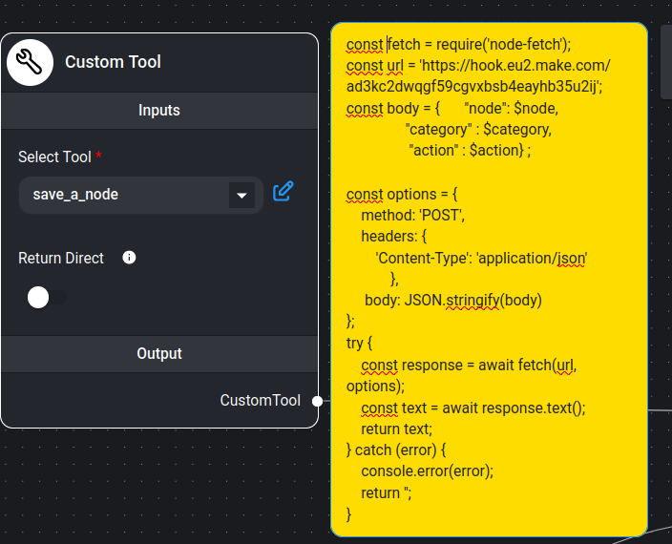Figure 14: This is the complete code written in custom tool.

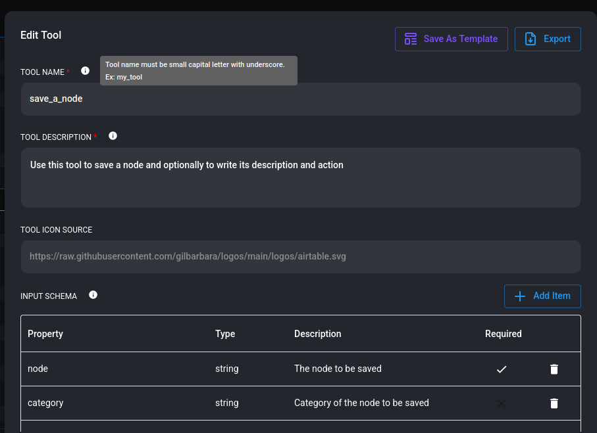

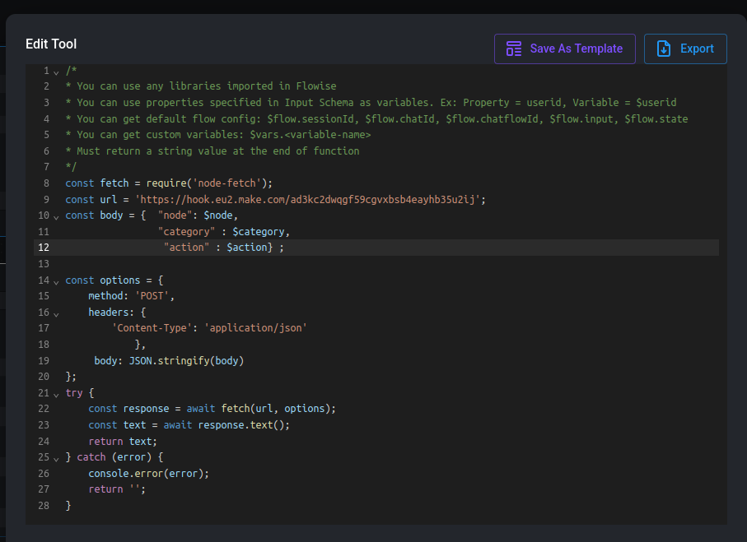

JS Code

/*
* You can use any libraries imported in Flowise
* You can use properties specified in Input Schema as variables. Ex: Property = userid, Variable = $userid
* You can get default flow config: $flow.sessionId, $flow.chatId, $flow.chatflowId, $flow.input, $flow.state
* You can get custom variables: $vars.<variable-name>
* Must return a string value at the end of function
*/
const fetch = require('node-fetch');

// Change as per your requirements below:
// url is the URL of the webhook
const url = 'https://hook.eu2.make.com/ad3kc2dwqgf59cgvxbsb4eayhb35u2ij';
const body = { "node": $node,
"category" : $category,
"action" : $action} ;

// Do not change the code below
const options = {
method: 'POST',
headers: {
'Content-Type': 'application/json'
},
body: JSON.stringify(body)
};
try {
const response = await fetch(url, options);
const text = await response.text();
return text;
} catch (error) {
console.error(error);
return '';
}





